PRINCIPLES OF EFFECTUATION

VISUALISE JOURNEY FOR 3 TO 5 YEARS

The industry that I am venturing into is the Upcycling or the sustainability Industry. My vision is to create a complete closed loop structure and experiment with everything in the field of Upcycling as well as Recycling.

The name of my venture is ‘ROOH’- To Eternity and Beyond The name is based on the ideology that things go away but souls remain. Through upcycling, I believe my company is giving them the new life and though the real state is gone but their soul still remains in the repurposed or restructured way.

The principles of Effectuation are as follows:

1. The Bird in Hand: This first principle talks about just starting off with the minimum available resources that are available at disposal right now and not wait for the perfect opportunity or huge investment.
2. The Affordable loss: This principle tells you to focus on evaluating the downside of the opportunity and not just the predicted upside of the initiative. It is always recommended to invest in the amount while starting that you are ready and okay to lose. Invest what you can afford to lose.
3. The Crazy Quilt: Partnerships and collaborations are considered to be the utmost best thing to do while starting a venture. By building a crazy or best form of partnership and collaboration, it is possible to achieve anything.
4. Lemonade: When life throws lemons at you, make lemonade out of it. When life gives you opportunities, grab them and make the most out of it.
5. Pilot-in-the-plane: We ourselves are the pilots in the plane. Our venture will get direction only through us. Its success or crash landing all depends on us and our actions. We define what our company is. Our companies are a reflection of who we are as well. Founder’s attitudes, intellect, passion all play a part in it.

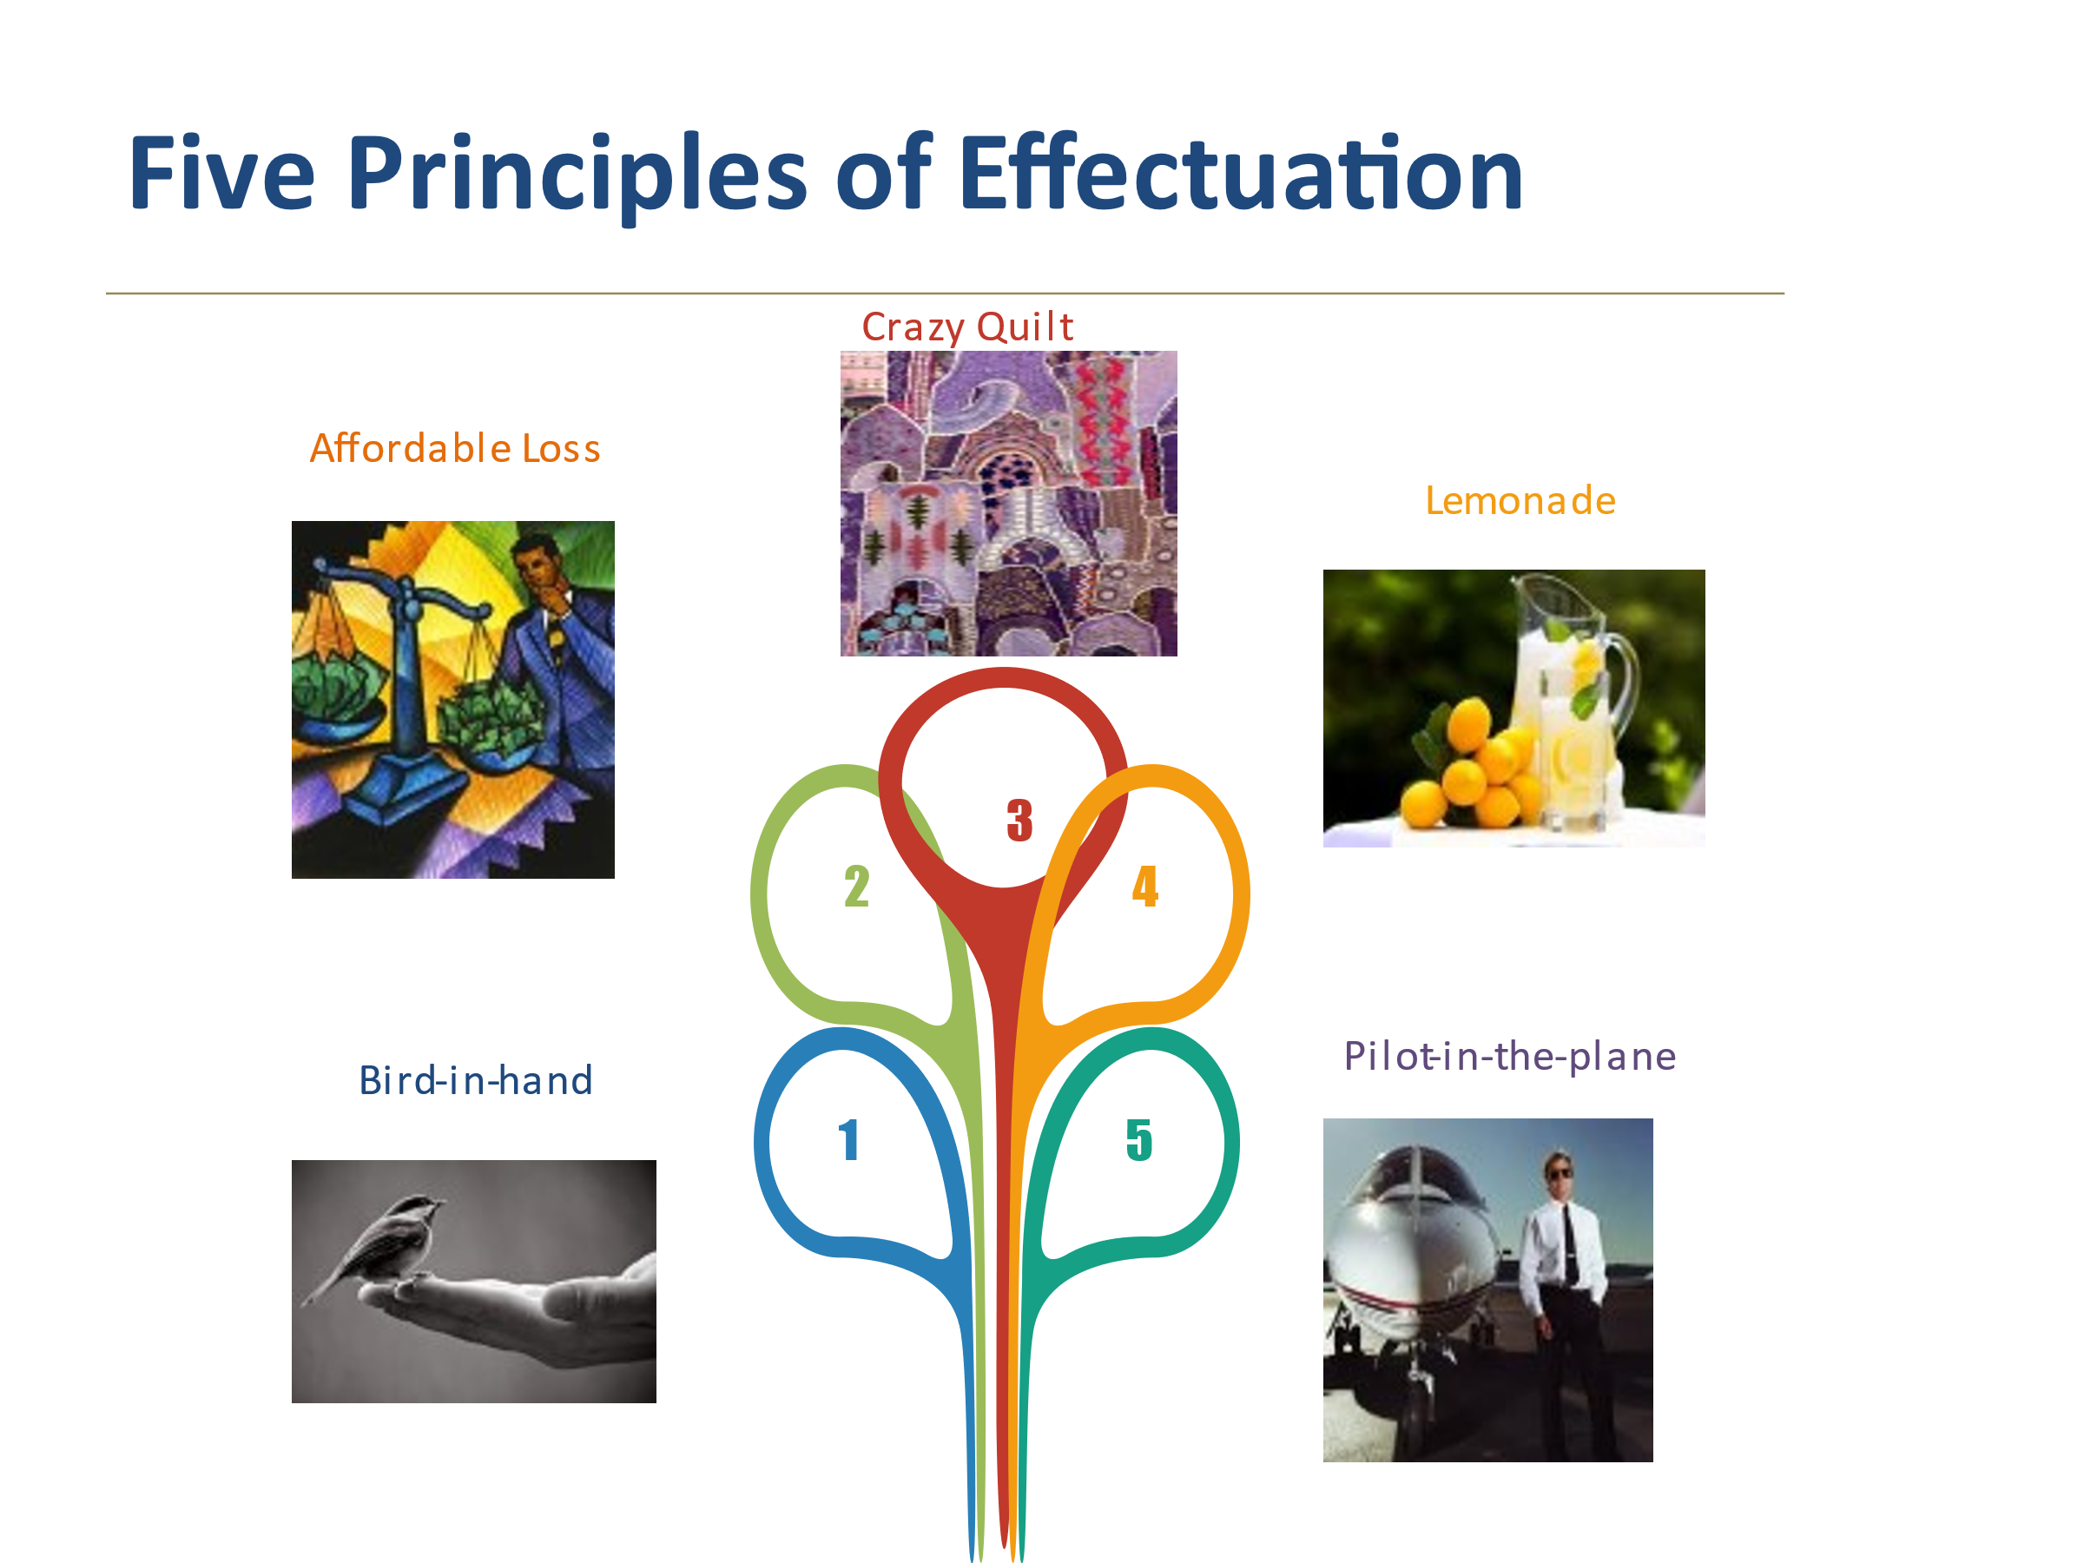

Currently, I am at a very initial stage wherein I have just started off by utilising the Bird in Hand starting right from the my network of wholesalers, tailors, boutique owners from whom I have procured the cloth waste to my photographers(to upload pictures on social media) to listing or displaying the products at my own retail store initially to test. I have also taken into consideration the affordable loss principle as I started ROOH with my own pocket money that I could easily use and not be worried a lot about losing it or going bankrupt at its worst. This is the most basic version of my business as my plan is to have a collaborative tech platform for thrifters and upcyclers. Rooh is a venture to test the market and have a taste of its working and trends.

My Visualisation:

Establish ‘Rooh’ as a brand through promotions, partnerships and collaborations locally and on the internet.

A Facebook community for upcycling collaborations. The idea is to build a community where sellers meet the buyers(thrifters). Once the idea is validated and there are enough buyers of the idea, work on building the tech platform which is like the FIVERR for SUSTAINABILITY wherein sellers can sell their thriftable or upcycled clothes and other items and buyers can buy the same from the platform. The role of the platform would be to maintain quality standards and earn through commission per transaction. This community is what I think is the CRAZY QUILT in my idea wherein all of them come together to do wonders and contribute towards making the world a cleaner and better place to live in.

Once proper validation and enough market is captured, the tech platform would be launched. This is where there would be an end to my bootstrapping and an investment would be required to build and grow the tech platform. My network is what I will reach out to first and if, not enough is raised, then outside investments would be called for by participating in various pitching investment competitions and incubators.